Name: _____________________________________________________________ Date: ________________ Per: ______________
Transformations Review
Answer each of the following questions. Be sure to show all necessary work.
_____ 1) If is the image of , under which transformation will the triangles not be congruent?
(1) reflection over the x-axis (2) translation to the left 5 and down 4
(3) dilation centered at the origin with scale factor 2 (4) rotation of 270° counterclockwise about the origin

_____ 2) A sequence of transformations maps rectangle ABCD onto rectangle A"B"C"D", as shown in the diagram below.

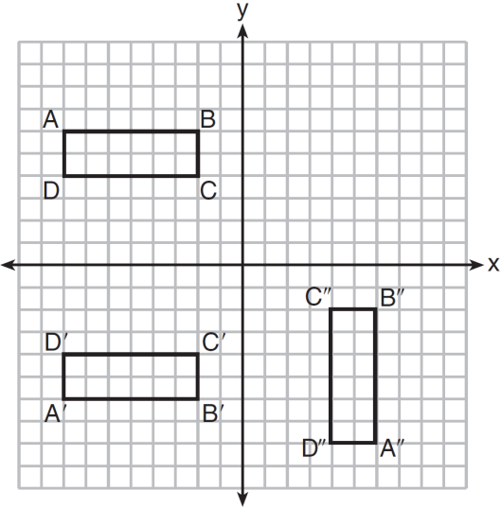

Which sequence of transformations maps ABCD onto A'B'C'D' and then maps A'B'C'D' onto A"B"C"D"?
1) | a reflection followed by a rotation
2) | a reflection followed by a translation
3) | a translation followed by a rotation
4) | a translation followed by a reflection

3) Reflect quadrilateral ABCD in the x axis, and then the y axis. Be sure to identify all of your coordinates.
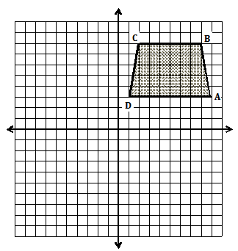

4) Triangle ABC has vertices with $A\left(3, 3\right), B\left(-3, -1\right), and C( -1, -4)$ Graph and label ∆ABC and ∆A’’B’’C’’, the image of ∆ABC after $R_{-90}o T_{(-3, 5)}$
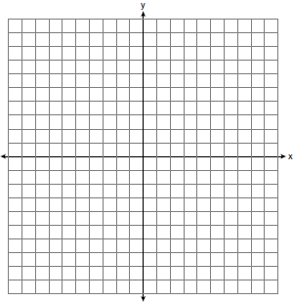

- Precisely define each of the three rigid motion transformations identified below:

- $R_{C,90}\left(∆ABC\right)$ ____________________________________________________________________

- $T_{\left(-2, 5\right)}(∆ABC)$ ____________________________________________________________________

- $r_{y=x}$____________________________________________________________________

- Translate ∆EFG along $\vec{CD}$, below.
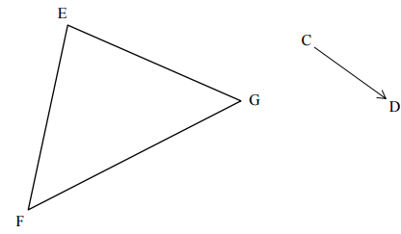

- Rotate ∆ABC 60º about point P.

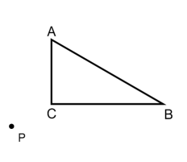

- Find the center of rotation that mapped ∆ABC onto ∆A’B’C’ below:
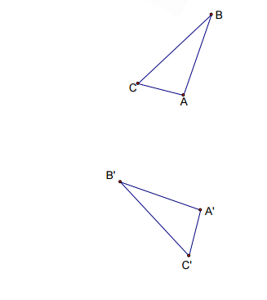

- Sketch the image of PQRS after a translation of 3 units down and 2 units left. Be sure to sketch the vector of translation.
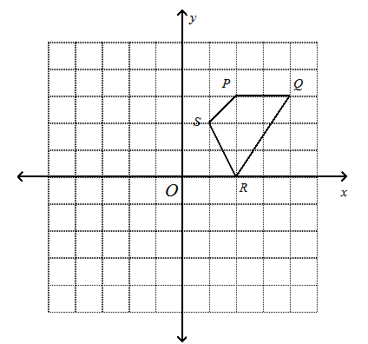
- Determine the line of reflection of the pre-image and its image below:

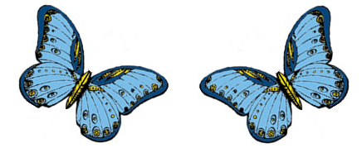

- Identify the series of rigid motions that mapped ∆XYZ onto ∆X”Y”Z”. Be sure to use proper function notation.
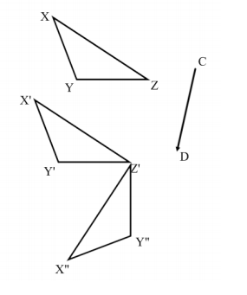
- Perform the indicated operation(s) on ∆CAT below: $R_{C,60}o T_{\vec{HE}}$
