Name: ________________________________________________ Date: _______________  
Common Core Geometry Period: _____________

**Chapter 2 REVIEW**

I. Constructions

1. Construct an angle bisector for the given angle

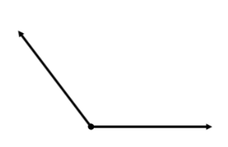

2. Find the circumcenter of the triangle

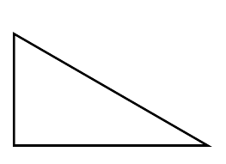

3. Copy the given angle

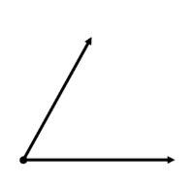

II. Find the value of $x$

|  |  |
| --- | --- |
| 4. | 5. |
| 6. | 7. |
| 8. $m∠2=x+94$ | 9. $m∠2=4x-2$ |
| 10. $m∠2=12x+4$ | 11. |

|  |  |
| --- | --- |
| 12. | 13. |
| 14. | 15. |
| 16. Find the measure in $∠b$ | 17. Find the measure in $∠b$ |
| 18. Find the measure in $∠b$ | 19. Find the measure in |

|  |  |
| --- | --- |
| 20. Find the measure in $∠x$ | 21. Find the measure in $∠x$ |
| 22. Find the measure in $∠x$ | 23. Find the measure in $∠x$ |
| 24. Find the measure in $∠x$ | 25. Find the measure in $∠x$ |
| 26. Find the measure in $∠x$ | 27. Find the measure in |

|  |  |
| --- | --- |
| 28. Find the measure in $∠x$ | 29. Find the measure in $∠x$ |
| 30. Find the measure in $∠x$ | 31. Find the measure in $∠b$ |
| 32. Solve for $y$ | 33. Solve for $x$ |
| 34. Solve for $x$ | 35. Solve for |

36. In , , & the measure of an exterior angle at A is $4x$. Draw a sketch & find .

37. In , , & the measure of an exterior angle at A is 2 $x$. Draw a sketch & find $x$.

|  |  |
| --- | --- |
| 38. Solve for $x$ | 39. Solve for $x$ |
| 40. Solve for $x$ | 41. Solve for $x$ |
| 42. Solve for $x$ | 43. Solve for $x$ |
| 44. Find both angles | 45. Find both angles |
| 46. Find both angles | 47. Find both angles |