Name: ________________________________________________ Date: _______________
Foundations of Geometry Period: _____________
Unknown Angles REVIEW
I. Vocabulary
A. Vertex, Sides, Angles
B. Acute, Right, Obtuse, Straight Angles
C. Supplementary angles add up to ____________
D. Complementary angles add up to ____________
E. Adjacent angles share a ________________________ and ________________________
F. Linear pairs add up to ____________
G. Vertical Angles are ________________________
H. Consecutive Adjacent Angles on a Line add to ____________
I. Angles Around a Point add to ____________
II. Name all sides, vertices, and angles. Be sure to name each angle four (4) different ways.
1.
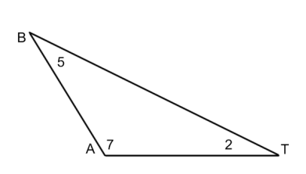
Sides ______________________________________________
Vertices ___________________________________________
Angles
_____________________________________________________
_____________________________________________________
_____________________________________________________
III. Identify if the following angles are acute, straight, right, or obtuse
2. 127 3. 90 4. 179 5. 81 6. 180
7. 8. 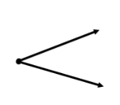 9. 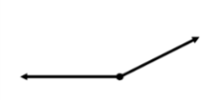 10. 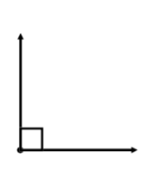

IV. Solve for $x$the missing angles
11.  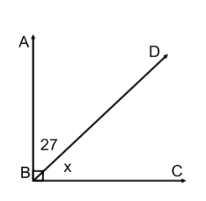 | 12.  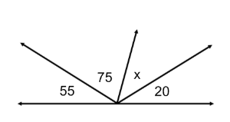 | 13.  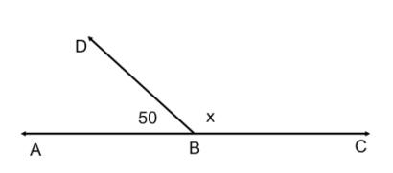
14.  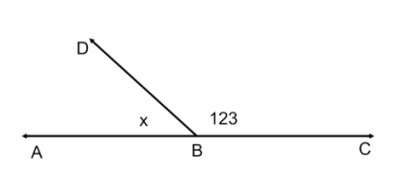 | 15.  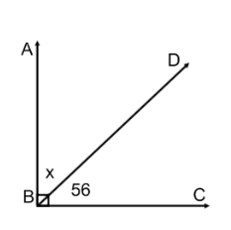 | 16.  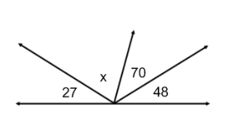
17.  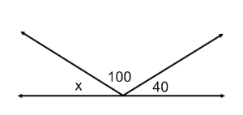 | 18.  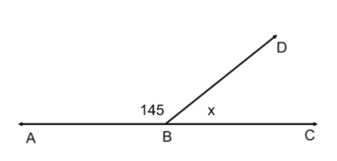 | 19.  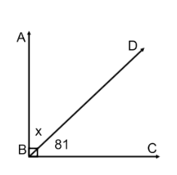
20.  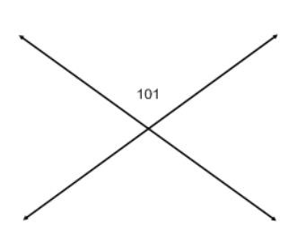 | 21.  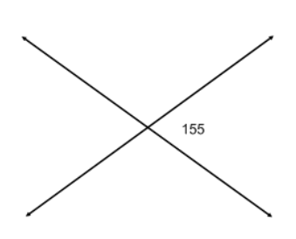 | 23.  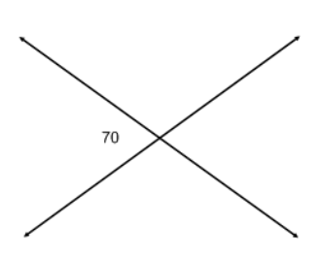

24. What is the complement of $42°$? 25. What is the supplement of $111°$?
25. What is the complement of $11°$? 26. What is the supplement of $15°$?

27. Solve for $x$ and find $∠MOP$  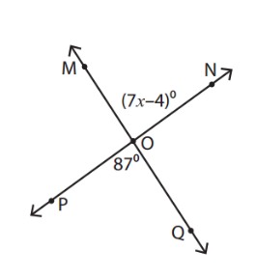 | 28. Solve for $x$ and find $∠COD$  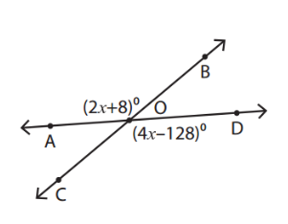
29. Solve for $x$ and find both angles  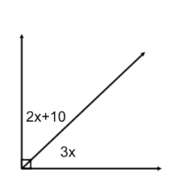 | 30. Solve for $x$ and find both angles  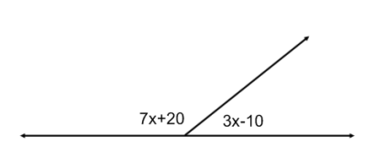

31. Solve for $x$ and find both angles  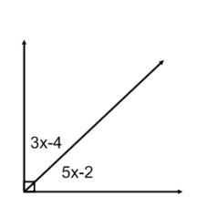 | 32. Solve for $x$ and find both angles  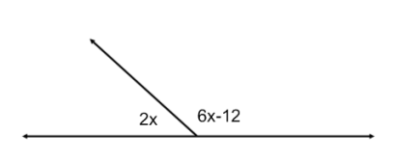
33. Solve for $x$ and find both angles  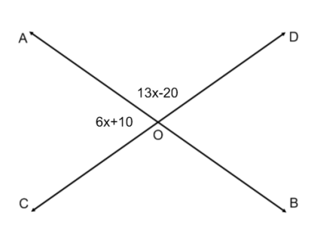 | 34. Solve for $x$ and find all angles  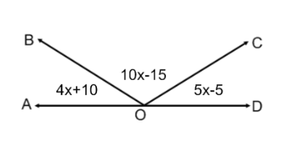
35. Solve for $x$ and find all angles  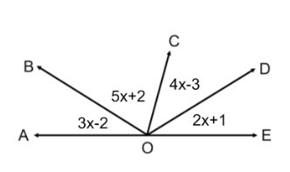 | 36. Solve for $x$ and find both angles  