Name: ________________________________________________ Date: _______________  
Common Core Geometry Period: _____________

**Chapter 2 Extra Review – Unknown Angles**

|  |  |
| --- | --- |
| 1. In the accompanying diagram, lines *a* and *b* are parallel and line *c* is a transversal. List a pair of  alternate interior angles ____________________  corresponding angles ____________________  alternate exterior angles ____________________  same side interior angles ____________________ | 2. In the diagram below of two parallel lines cut by a transversal, $m∠1=5x+12$ and $m∠2=7x$.  Find $m∠1$.  1  2 |
| 3. Which choice below may ***not*** be used to name $∠AIR$?    (1) $∠RIA$ (2) $∠I$ (3) $∠5$ (4) $∠RAI$ | 4. |
| 5. The number of degrees in the measure of each of a pair of *vertical angles* formed by two intersecting lines is represented by 6*x* + 10 and 5*x* + 25. Find the measure of one of these angles. | 6. The measures of the angles of a triangle are 2x, 3x, and 4x. The measure of the *largest* angle of this triangle is |

**Part II:**

7. Find the value of $x$. 8. Find the value of $x$.

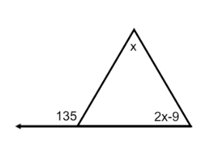

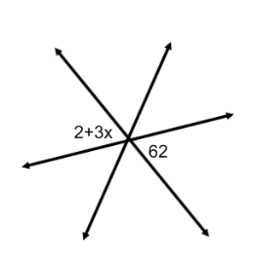

**Part III:**

9. Using the figure below and the given information, find the value of $x$ and $m∠BOE$. SHOW ALL WORK!

$m∠AOC=101$, $m∠COD=44$, $m∠BOC=70$

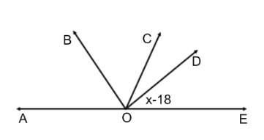

**Part IV:**

10. In the figure below, $\overset{⃡}{AB}$ and $\overset{⃡}{CD}$ are straight lines that intersect at O. $\overline{EO}⊥\overset{⃡}{AB}$.

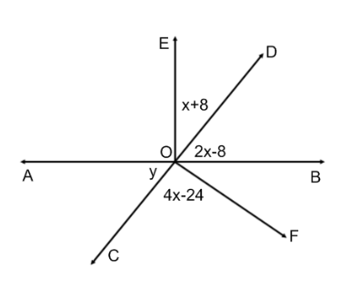

Find the following and give a reason for each step.

x = ________

y =

$m∠BOF=$

 ________

________