Name: ________________________________________________ Date: _______________
Common Core Geometry Period: _____________
Chapter 7 REVIEW
I. Radicals
1. Express $\sqrt{32}$ in simplest radical form

2. Express $2\sqrt{45}$ in simplest radical form

3. Express $3\sqrt{250}$ in simplest radical form

4. Find the sum of $\sqrt{18}$ and $\sqrt{72}$

5. Find the sum of $\sqrt{150}$ and $\sqrt{24}$

6. Simplify $2\sqrt{50}-\sqrt{2}$

7. Simplify $\sqrt{75}-3\sqrt{27}$

8. Simplify $\sqrt{48}-5\sqrt{27}+2\sqrt{108}$

9. Express in simplest radical form $\sqrt{6}∙\sqrt{15}$

10. Express in simplest radical form $\sqrt{8}∙\sqrt{12}$

11. Express in simplest radical form $8\sqrt{12}∙3\sqrt{24}$

12. Simplify $\frac{6\sqrt{20}}{3\sqrt{5}}$

13. Simplify $\frac{\sqrt{84}}{2\sqrt{3}}$

II. Right Triangles
14. In the diagram below of right triangle ABC, an altitude is drawn to the hypotenuse . Which proportion would always represent a correct relationship of the segments?
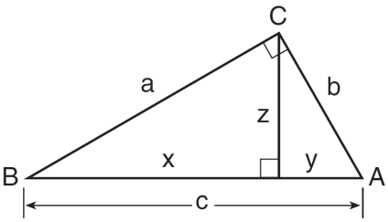
1) | 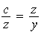
2) | 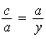
3) | 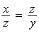
4) | 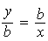

15. In the diagram below of right triangle ABC, altitude is drawn to hypotenuse . If and , what is the length of altitude ?
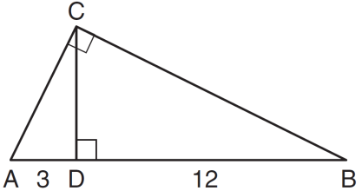

16. In the diagram below of right triangle ABC, altitude is drawn to hypotenuse , , and . What is the length of ?

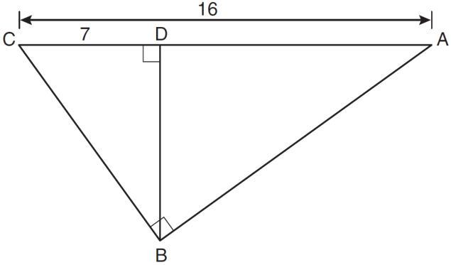

17. In right triangle ABC below, is the altitude to hypotenuse . If and the ratio of AD to AB is 1:5, determine and state the length of . [Only an algebraic solution can receive full credit.]

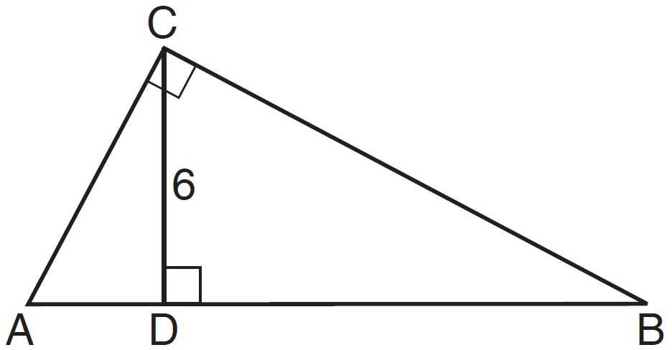

18. In the diagram below of right triangle ACB, altitude is drawn to hypotenuse . If and , what is the length of ?
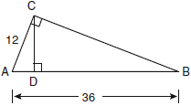

19. In the diagram below of right triangle ABC, is the altitude to hypotenuse , , and . What is the length of ?
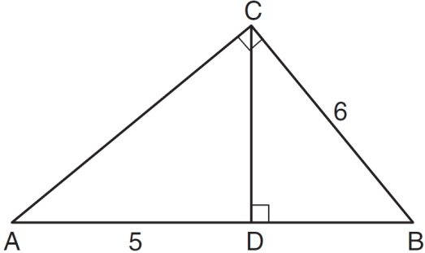

20. In right triangle ABC shown in the diagram below, altitude is drawn to hypotenuse , , and . What is the length of ?
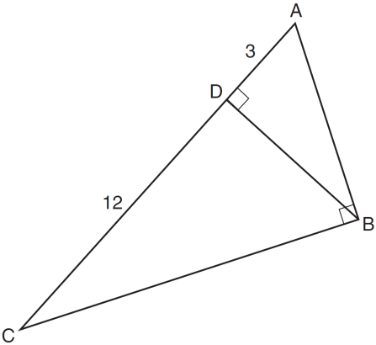

21. In the diagram below, right triangle RSU is inscribed in circle O, and is the altitude drawn to hypotenuse . The length of is 16 more than the length of and . Find the length of . Find, in simplest radical form, the length of .
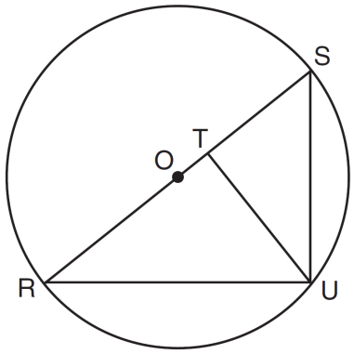

22. The lengths of the sides of a right triangle can be
1)
2)
3)
4)

23. The length of one side of a square is 13 feet. What is the length, to the nearest foot, of a diagonal of the square?

24. In triangle RST, angle R is a right angle. If and , what is the length of ?
1) | 10
2) | 2
3)
4)

25. The accompanying diagram shows a kite that has been secured to a stake in the ground with a 20-foot string. The kite is located 12 feet from the ground, directly over point X. What is the distance, in feet, between the stake and point X? What is the angle of elevation of the kite?
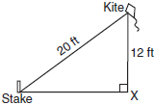

26. In the accompanying diagram of right triangles ABD and DBC, , , & . Find the length of , to the nearest tenth.
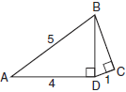

27. In below, the measure of , , , and . Find the sine, cosine, and tangent of angle B.
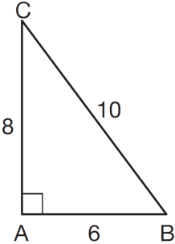

28. In triangle MCT, the measure of , , , and . Find the sine, cosine, and tangent of angle C.

29. In right triangle JKL in the diagram below, , , , and . Which statement is not true?
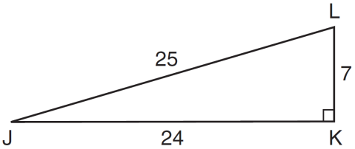
1) | 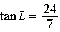
2) | 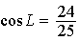
3) | 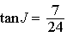
4) | 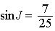

30. In the right triangle shown in the diagram below, what is the value of x to the nearest whole number?
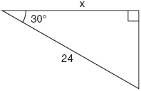

31. As shown in the diagram below, a building casts a 72-foot shadow on the ground when the angle of elevation of the Sun is 40°. How tall is the building, to the nearest foot?
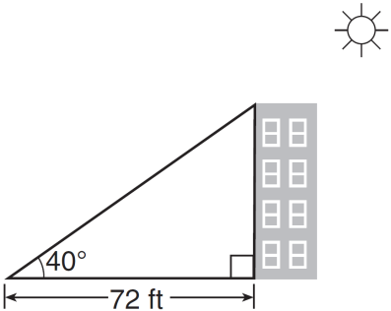

32. A right triangle contains a 38° angle whose opposite side measures 10 centimeters. What is the length of the hypotenuse, to the nearest hundredth of a centimeter?

33. A stake is to be driven into the ground away from the base of a 50-foot pole, as shown in the diagram below. A wire from the stake on the ground to the top of the pole is to be installed at an angle of elevation of 52°. How far away from the base of the pole should the stake be driven in, to the nearest foot? What will be the length of the wire from the stake to the top of the pole, to the nearest foot?
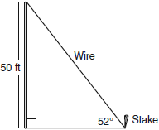

34. Cassandra is calculating the measure of angle A in right triangle ABC, as shown in the accompanying diagram. She knows the lengths of and . If she finds the measure of angle A by solving only one equation, which concept will be used in her calculations?
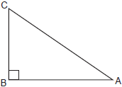
35. In the accompanying diagram, the base of a 15-foot ladder rests on the ground 4 feet from a 6-foot fence.
a If the ladder touches the top of the fence and the side of a building, what angle, to the nearest degree, does the ladder make with the ground?
b Using the angle found in part a, determine how far the top of the ladder reaches up the side of the building, to the nearest foot.
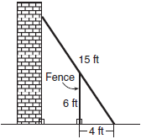

36. A person measures the angle of depression from the top of a wall to a point on the ground. The point is located on level ground 62 feet from the base of the wall and the angle of depression is 52°. How high is the wall, to the nearest tenth of a foot?

37. A tree casts a shadow that is 20 feet long. The angle of elevation from the end of the shadow to the top of the tree is 66°. Determine the height of the tree, to the nearest foot.

38. A ship on the ocean surface detects a sunken ship on the ocean floor at an angle of depression of 50°. The distance between the ship on the surface and the sunken ship on the ocean floor is 200 meters. If the ocean floor is level in this area, how far above the ocean floor, to the nearest meter, is the ship on the surface?

39. In , , , and . Find b to the nearest integer.

40. In , , , and . What is to the nearest degree?

41. In the accompanying diagram of a right triangle ACD, B lies on , is drawn such that , , and . Find AB to the nearest tenth.
