Name: ________________________________________________ REVIEW UNIT 1
Common Core Geometry Date: _______________
OBJECTIVE: Am I ready to answer this question on a quiz or test?
1. Using your compass, construct equilateral triangles with bases of $\overline{AB}$ and $\overline{DE}$ as shown. Leave all marks.

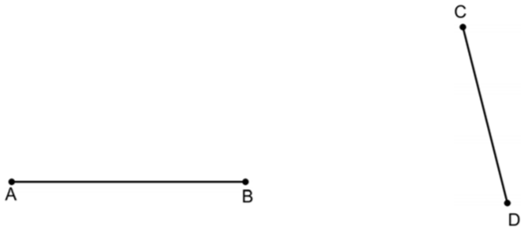
2. Find the values of AB, BC, and AC in the diagram with your ruler. Round your answers to the nearest millimeter.
AB = __________
BC = __________
AC = __________

3. Based on your values for found above for AB, BC, and AC, give an explanation for why points A, B, and C are NOT collinear.

4. In the diagram below, points M, N, and P are collinear. If $MN=3x-9$, $NP=x+1$, and $MP=6x-22$, solve for the value of $x$ and each line segment. The diagram is not drawn to scale.
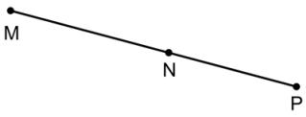

5. Using your answers from #4, is point N the midpoint of $\overline{MP}$? Explain your answer.

6. In the diagram, it is known that $\overline{ABC}$, $m∠EBC=140$, and $m∠CBD=35$. The diagram is not drawn to scale.
(a) Find $m∠EBD$ and $m∠ABE$
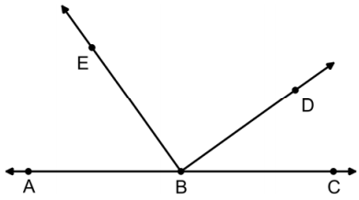

(b) Is $\vec{BE} ⊥ \vec{BD}$? Justify based on part (a)

7. $∠DAY$ is a right angle. If $m∠DAY = \frac{1}{2}x+34$, then solve for value of $x$ algebraically.

8. If $m∠TMI=5x+2$ and $x=20$, then classify $∠TMI$ as acute, obtuse, right, or straight. Give an explanation.

9. Two angles, $∠A$ and $∠B$, are supplementary to one another. If , are supplementary to one another. If $m∠B$ is 30 degrees more than $m∠A$, find the measure of both angles.

10. In the diagram, points A, B, and C are collinear and $\vec{BE} ⊥ \vec{AC}$.
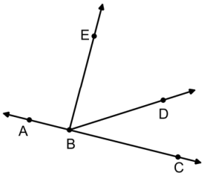
(a) State one pair of complementary angles.

(b) State two pairs of supplementary angles.

11. Use your compass to find two points that are 2 inches away from point A and 1.5 inches away from point B.

12. Use your protractor to draw an angle bisector of $∠CAT$. State the number of degrees in $∠CAT$ and one of the bisected angles.
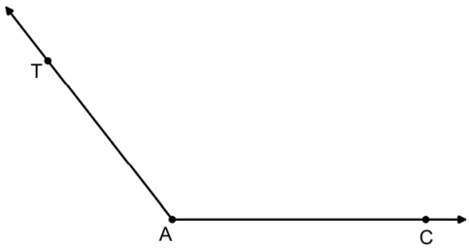

13. Using your compass, construct a triangle with side lengths of 3 cm, 4 cm, and 6 cm. How do you know you can construct a triangle with these side lengths before you begin?

14. Using your compass, construct $∆DEF$ such that $∆DEF ≅ ∆ABC$.

15. In the diagram, it is given that $\overline{RS}$ bisects $\overline{MN}$ at point P. Which of the following statements below does not have to be true? Explain your choice without using your ruler to measure.
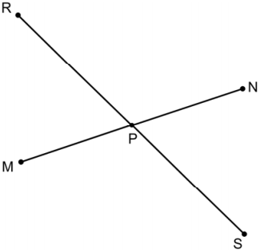
(1) $MP=NP$
(2) $RP+PS=RS$
(3) P is the midpoint of $\overline{RS}$
(4) P is the midpoint of $\overline{MN}$

6. In the diagram, $\vec{CE} ⊥ \vec{AB}$ and $\vec{CF} ⊥ \vec{CD}$. If $m∠BCD=25$, then find the $m∠1$, $m∠2$, and $m∠3$.
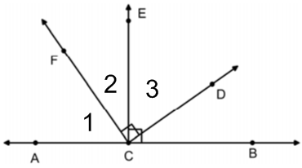
17. Given $\overline{AB}$ & $\overline{DE}$ bisect each other. If F is the midpoint of $\overline{DC}$, $AB=34$ and $DE=16$, find the value of $FC+CB$.
