Geometry Midterm Review

Name: ______________________

Unit 1 – Beginning Geometry

_____ 1. Given: ∆ABD, $\overline{BC}$ is the altitude of ∆ABD.
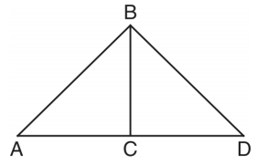
Which statement is always true?
- $\overline{AC}≅\overline{DC}$
- ∠ACB ≅ ∠DCB
- AC ≅ CD
- $\overline{BC}≅\overline{CD}$

_____ 2. Which numbers could represent the lengths of the sides of a triangle?
- 5, 9, 14
- 7, 7, 15
- 1, 2, 4
- 3, 6, 8

_____ 3. Which of the following is not an acceptable way to identify the angle below?
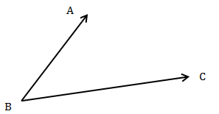
- ∠B
- ∠ABC
- ∠CBA
- ∠CAB

_____ 4. Two supplementary angles are in the ratio 5:4. The number of degrees in the smaller angle is:
- 100 (2) 80 (3) 40 (4)20

_____ 5. In scalene triangle ABC, and . What is the order of the sides in length, from longest to shortest?
(1) | , ,
(2) | , ,
(3) | , ,
(4) | , ,

6. In the accompanying diagram, $\overset{⃡}{AB}$ and $\overset{⃡}{CD}$ intersect at E. If m∠AEC = 2x – 6 and m∠DEB = 6x – 50, determine the m∠AED.
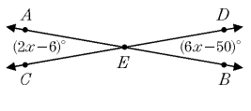

7. In the accompanying diagram, $\overset{⃡}{ABC}$ is a straight line and $\vec{BE}$ bisects ∠DBC. If m∠ABD = 3x and m∠DBE = 2x + 16, find x.

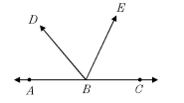
Thought Box:

Unit 2 – Transformations
_____ 1. If an octagon is rotated clockwise about its center, the minimum number of degrees it must be rotated to carry the octagon onto itself is
(1) 45 (2) 72 (3) 108 (4) 360

_____ 2. If A is the ordered pair (2, 3) and A” is the order pair (- 4, 6), which of the following series of rigid motions have occurred?

(1) $r_{y axis }o T_{2,3}$
(2) $T_{2,3}o{ r}_{y axis}$
(3) $T_{2,3}o R_{90}$
(3) $r_{x axis} o T_{3, 2}$

_____ 3. As shown in the diagram below, when right triangle DAB is reflected over the x-axis, its image is triangle DCB.

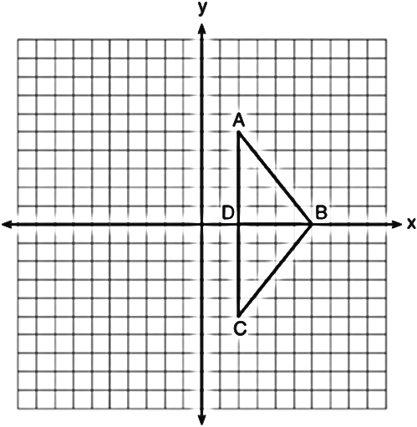

_____ 4. If point P(3, 2) is rotated clockwise 90 degrees about the origin its image P’ will be:
(1) P’(3, ―2) (2) P’(2, ―3) (3) P’(―2, 3) (4) P’(―3, ―2)

Which statement justifies why ?
1) | Distance is preserved under reflection.
2) | Orientation is preserved under reflection.
3) | Points on the line of reflection remain invariant.
4) | Right angles remain congruent under reflection.

5. Using a compass and straightedge, determine the line of reflection for the figure below.
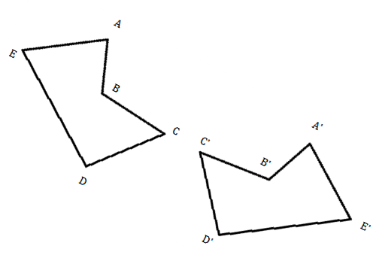
Explain why ABCDE is congruent to A’B’C’D’E’ using properties of rigid motions.
6. Given the coordinates of A(1, 1), B(4, 1), and C(4, 6), sketch and label the coordinates of ∆A”B”C” after a reflection in the x axis followed by a translation of four units left and 6 units up.
Explain why ∆ABC ≅ ∆A”B”C”

Thought Box:

Unit 3 – Triangles and Congruency
_____ 1. In the diagram below of , .
Using this information, which of the following is true?
- (2) (3) (4)

_____ 2. Which of the following is not an acceptable method for proving two triangles are congruent?
- SAS (2) SSS (3) HL (4) SSA

_____ 3. In the diagram below, , , and .

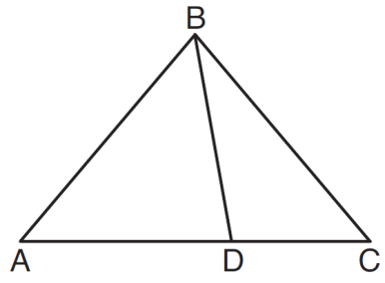
Which statement is true?
1) | is obtuse.
2) | is isosceles.
3)
4) | is scalene.

4. In , , , and . Determine the value of x. Classify the triangle by sides and angles.

5. In the diagram below, is shown with extended through point D. If , , and , what is the value of x?
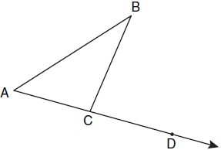

6. Line n intersects lines l and m, forming the angles shown in the diagram below. Determine the value of x.
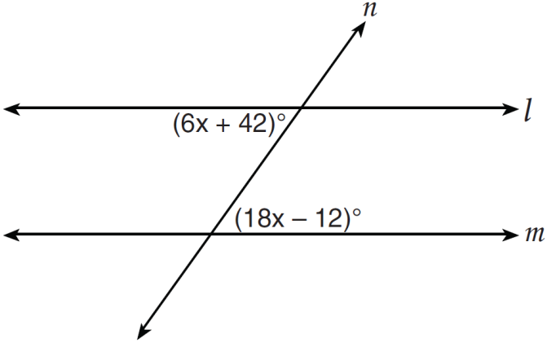
7. Given: Quadrilateral ABCD below with AB = CD, $\overline{AB}⟘{\overline{BC}, \overline{ CD}⟘\overline{BC}}$, and BE = FC.
Prove: AF = DE

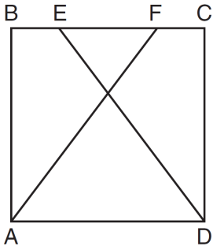
Thought Box:

Unit 4 – Constructions

_____ 1. Joey sketches a circle inside of a triangle such that the circle intersects each side of the triangle in exactly one point. Which of the following constructions can he do to the triangle to determine the center of the circle?

- Construct the three angle bisectors of the triangle
- Construct the three perpendicular bisectors of the triangle
- Construct the diameter of the circle
- Neither

_____ 2. Based on the construction below, which conclusion is not always true?

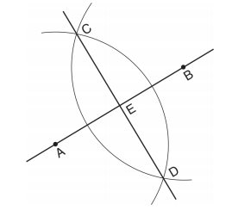
- $\overline{AB}$ ⟘$\overline{CD}$
- AB = CD
- AE = EB
- CE = DE

3. Using a compass and straightedge, sketch the line perpendicular to line m below that passes through point P.
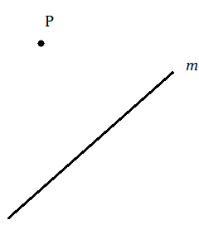

4. Using a compass and straightedge, create an angle congruent to ∠ABC below.
5. Using your compass, construct ∆XYZ such that ∆XYZ ≅ ∆ABC.
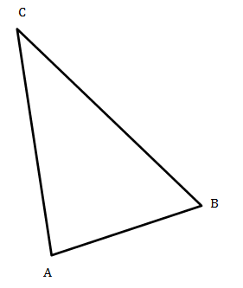
Thought Box:

Unit 5 - Coordinate Geometry
_____ 1. Which of the following represents the slope of a line passing through the points (3, 4) & (7, 8)?
1) 4 2) 1
3) - 4 4) - 1

_____ 2. Which of the following represents a line parallel to a line with the equation $y=2x-5$?
1) $y=2x+1$ 2) $y=\frac{1}{2}x-2$
3) $y=-2x+1$ 4) $y=-\frac{1}{2}x-5$

_____ 3. Which of the following represents the length of a line whose endpoints are (2, 6) & ( - 4, - 2)?
1) 100 2) 10
3) $\sqrt{20}$ 4) $2\sqrt{7}$

4. The midpoint of $\overline{AB}$ is $M\left(4, 5\right)$. If the coordinates of $B$ are $\left(8, -1\right)$, what are the coordinates of $A$? The use of the graph is optional.
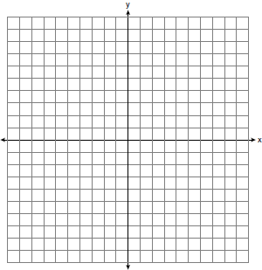
5. Given a line has endpoints of $\left(-2,5\right)$ and (6, - 4). Determine the equation of the perpendicular bisector to the line. [Use of the grid below is optional]
Thought Box:

Unit 6 – Quadrilaterals and Coordinate Proof
_____ 1. Quadrilateral ABCD has diagonals $\overline{AC}$ and $\overline{BD}$. Which information is not sufficient to prove ABCD is a parallelogram?
1) $\overline{AC}$ and $\overline{BD}$ bisect each other
2) $\overline{AB} ≅ \overline{CD}$ and $\overline{BC} ≅ \overline{AD}$
3) $\overline{AB} ≅ \overline{CD}$ and $\overline{AB} ∥ \overline{CD}$
4) $\overline{AB} ≅ \overline{CD}$ and $\overline{BC} ∥ \overline{AD}$

_____ 2. Given three distinct quadrilaterals, a square, rectangle, and a rhombus, which quadrilaterals have diagonals that bisect each other?

1) rectangle only
2) rectangle and square
3) rhombus and square
4) rectangle, rhombus, and square

3. Two consecutive angles of a parallelogram measure $3x+20$ an $7x-40$. Find the value of $x$.

4. Determine the length of each side of a rhombus, to the nearest tenth, whose diagonals measure 20 and 15.

5. In the coordinate plane, the vertices of $∆RST$ are $R\left(6, -1\right), S\left(1, -4\right), and T\left(-5, 6\right)$. Prove that $∆RST$ is a right triangle.
6. The vertices of quadrilateral $DEFG$ are $D\left(3, 2\right)$, $E\left(7, 4\right)$, $F\left(9, 8\right)$ and $G\left(5, 6\right)$. Using coordinate geometry, prove that DEFG is a parallelogram, but not a rectangle. [Use of the grid below is optional]

7. The vertices of quadrilateral $GRID$ are $G\left(4, 1\right)$, $R\left(7, -3\right)$, $I\left(11, 0\right)$ and $D\left(8, 4\right)$. Using coordinate geometry, prove that quadrilateral $GRID$ is a square. [Use of the grid below is optional]

Thought Box:

